General inspection
Postural abnormalities or deformities
Muscle wasting
Fasciculations
Abnormal movements
Tone
‘Roll’ legs side to side on bed
Flex and extend knee
Rotate ankle
Test for clonus – Upon forceful plantarflexion a patient involuntarily repeats the plantarflexion motion
Power
Hips flexion
Hips abduction – Not and against force
Hips adduction – Not and against force
Hips extension – Not and against force
Knees flexion – Not and against force
Knees extension – Not and against force
Ankle dorsiflexion – Not and against force
Ankle plantarflexion – Not and against force
Big toe extension – Not and against force
Coordination
Run heel of one leg up the shin of the other
Tap each foot on the ground
Tendon reflexes
Knee (L4, L4)
Ankle (S1)
Plantar response – Scrape sole upwards towards toes. Toe flexion is expected. Toe extension and fanning is abnormal.
Sensation – Light soft touch
Upper part of the upper leg (L2)
Lower-medial part of upper leg (L3)
Medial lower leg (L4)
Lateral lower leg (L5)
Sole of foot (S1)
Back of upper leg (S2)
Sensation – ‘Painful’ sharp touch
Upper part of the upper leg (L2)
Lower-medial part of upper leg (L3)
Medial lower leg (L4)
Lateral lower leg (L5)
Sole of foot (S1)
Back of upper leg (S2)
Sensation – Proprioception
Joint position sense – Ask patient to close eyes and flex and extend their knee. The patient is to state if their distal leg is in the up or down position.
Other
Gait
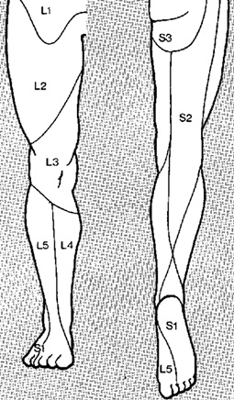
Romberg’s test – Ask patient to stand with feet close together and eyes closed. Observe sense of balance with or without pushing (if appropriate and with patient consent).

